Ocular Glimpse Of Covid-19 In Pakistan Using Tableau….

***Disclaimer:****Nowadays,**the major concern is spread of information particularly wrong information. As information can easily be violated.Similarly the given analysis of covid-19 is done by an unprofessional , it may contain errors and deletions. If you want to take an important step regarding Covid-19, please visit the official data analysis from the government.*

**Introduction:**

Coronavirus is an extensive family of viruses.Its one form that is novel **Covid-19** has got into our nerves. Almost **213** countries have been suffering from covid-19 till now. It majorly targets the respiratory tract and is carried through tiny tiny droplets. These droplets are produced as a result of coughing or sneezing of an infected person.

**Background:**

It basically originated from China then it spreads readily to the its neighbours. Pakistan got its first corona patient on **26th February 2020**, and by far now after 5 months we have reached a total of **95,000** cases with almost **1950** deaths. Its cure is still unknown. Furthermore, almost all the countries have gone through lockdowns but still it had spread across the globe like fire.

**Data Behind the Visuals:**

The initial step of any analysis is extracting the data from a reliable source. For that purpose, I have used a dataset by Mesum Raza Hemani. It comprises of 10 excel sheets. It is a comprehensive dataset that covers all the major aspects of Covid-19 in Pakistan. It has data from the start of spread till mid of the May. Original dataset link:

**[Corona Virus Pakistan Dataset 2020](https://www.kaggle.com/mesumraza/corona-virus-pakistan-dataset-2020" \t "_blank)**

[Corona Virus Pakistan Dataset 2020](https://www.kaggle.com/mesumraza/corona-virus-pakistan-dataset-2020" \t "_blank)

[Corona Virus Pakistan Dataset 2020www.kaggle.com](https://www.kaggle.com/mesumraza/corona-virus-pakistan-dataset-2020" \t "_blank)

**Data Cleaning :**

I have cleaned all the excel sheets using python. The Platform used was “**Jupyter Notebook**”. All the Data cleaning files are present in my project repository on git hub. Link to My Github Repository:

**[Syeda-Samana-Batool/DS\_project](https://github.com/Syeda-Samana-Batool/DS_project" \t "_blank)**

[Data visualizations on Covid-19 dataset. Contribute to Syeda-Samana-Batool/DS\_project development by creating an…](https://github.com/Syeda-Samana-Batool/DS_project" \t "_blank)

[github.com](https://github.com/Syeda-Samana-Batool/DS_project" \t "_blank)

**Tools:**

I have used “**Tablaeu Public 2020.2**” for making my visualizations. It is an amazing tool that offers a number of features for designing interactive dashboards.

**Covid-19 Data Visualizations:**

Data in most applicable in the form of graphics. It enables one to easily detect the trends and patterns of the data. I have tried my best to analyze the numeric data in the form of Interactive visuals so that the reader can get an accurate idea of covid-19 in Pakistan. I have designed 10 dashboards each of them representing one important aspect regarding this pandemic.

**1. Provincial Analysis of Suspected Cases:**

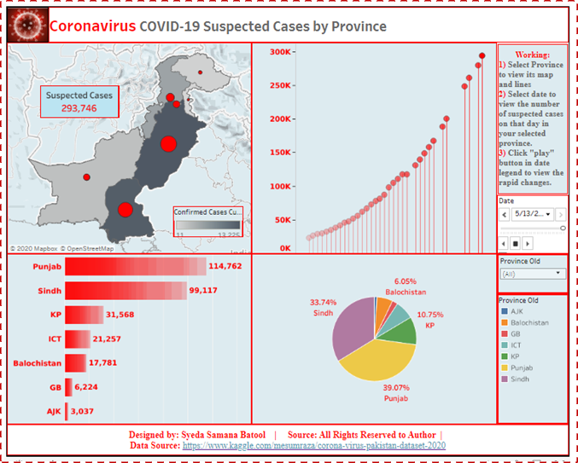

**Figure 1**

Figure 1 comprises of 4 graphs and 2 data legends:

***· Graphs:***

**Map of suspected cases and confirmed cases:**This map colour highlights the number of Total Suspected cases while the small bullets demonstrate the number of Confirmed cases out of those who were suspected.

**Lines of suspected cases:**These lines represent the constant rapid increase in the number of suspected cases.

**Bars of suspected cases:**They portray a comparative analysis of suspected.

**Pie of Suspected cases:**It gives a percentage of the total suspected cases in each province.

***· Data Legends:***

**Date:**It enables the person to view the number of suspected cases on a specific date. One click on the play button presents a clear picture of rapid changes with the passage of time.

**Province**: It provides an effective way to select a province of interest to view the corresponding graphs.

***· Observations:***

Figure 1 presents a visual display of rapid increase in the number of suspected cases. Using date legend, we have observed that suspected cases on the onset of April were **22,726** but till the 13th of May we have reached a total of **293,746** cases. Moreover, lines shows the continuous increase in the number. While comparative bars of provinces demonstrate that Punjab & Sindh have almost similar number of suspects at one time but now Punjab is at Lead. Among other provinces Azad Kashmir has the least number of suspects. Furthermore,pie chart exhibited that Punjab has got **39.07 %** andAzad Kashmir has got only **1.03 %**of totalsuspected cases.

***· Online Dashboard:***

**[Tableau Public](https://public.tableau.com/profile/syeda.samana.batool" \l "!/vizhome/SuspectedCases_15907790864260/SuspectedCases" \t "_blank)**

[Edit description](https://public.tableau.com/profile/syeda.samana.batool" \l "!/vizhome/SuspectedCases_15907790864260/SuspectedCases" \t "_blank)

[public.tableau.com](https://public.tableau.com/profile/syeda.samana.batool" \l "!/vizhome/SuspectedCases_15907790864260/SuspectedCases" \t "_blank)

**2. Provincial Analysis of Tests Performed:**

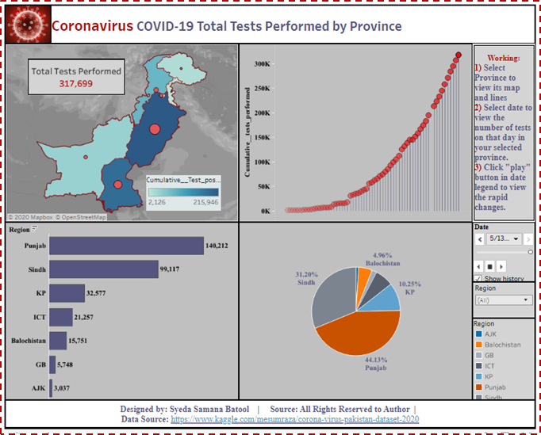

**Figure 2**

Figure 2 comprises of 4 graphs and 2 data legends:

***· Graphs:***

**Map Total Tests Performed and confirmed cases:**This map colour highlights the number of Total test performed while the small bullets demonstrate the number of Confirmed cases out of those who were tested.

**Lines of total tests:**These lines represent the rapid elevation in the number of tests.

**Bars of total tests:**They portray a comparative examination of total tests in each province.

**Pie of total tests:**It gives a percentage of the total tests w.r.t province.

***· Data Legends:***

**Date:**It allows one to view the number of tests on a specific date.

**Province**: It provides an effective way to select a province of your choice to view the its graphs.

***· Observations:***

Figure 2 above gives an visual depiction of extention in the number of total tests. With date legend, we have observed that cumulative tests on the onset of march were **422**, but till the 13th of may ,a total of **317,699** tests were coonducted. Futhermore, lines portrays that tests have constantly incremented in the months of April and May. Comparative bars illustrate that Punjab dominates the number of tests as well followed by sindh. Moreover, Gilgit Baltistan and Azad Kashmir has the lowest number of tests throughout because of lack of resources. Pie chart presents that Punjab has **44.13%** while Azad Kashmir has only **0.98%** of tests.

***· Online Dashboard:***

**[Tableau Public](https://public.tableau.com/profile/syeda.samana.batool" \l "!/vizhome/CummulativeTestsPerformed/TotalTestsPerformed" \t "_blank)**

[Edit description](https://public.tableau.com/profile/syeda.samana.batool" \l "!/vizhome/CummulativeTestsPerformed/TotalTestsPerformed" \t "_blank)

[public.tableau.com](https://public.tableau.com/profile/syeda.samana.batool" \l "!/vizhome/CummulativeTestsPerformed/TotalTestsPerformed" \t "_blank)

**3. Provincial Analysis of Confirmed Cases:**

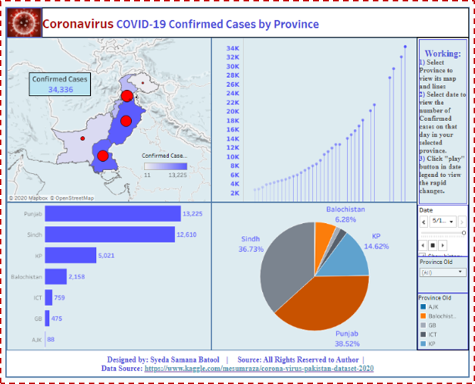

**Figure 3**

Figure 3 comprises of 4 graphs and 2 data legends:

***· Graphs:***

**Map of confirmed cases and total deaths:**This map colour highlights the number of confirmed cases while the small bullets demonstrate the number of Deaths out of those who were confirmed.

**Lines of Confirmed cases:**These lines represent the rapid increase in the number of confirmed cases.

**Bars of Confirmed cases:**They portray a comparative analysis of confirmed cases according to province.

**Pie of Confirmed cases:**It gives a percentage of the total confirmed cases in each province.

***· Data Legends:***

**Date:**It enables the person to view the number of confirmed cases on a particular date.

**Province**: It provides an effective way to select a province of your focus to view its visualizations.

***· Observations:***

Figure 3 gives a perceptible display of colossal increment in the number of individual tested positive. Date legend portrayed that the number of confirmed cases at the beginning of march were **2708**, but till the 13th of may we have reached a total of **34,366** confirmed cases. Lines exhibits the number of tested positive cases have excessively increased in the months of April and May. Comparative bars ilustrates that Punjab and Sindh has got almost same number of cases. Moreover, Islamabad has reduced number of confirmed cases than Gilgit baltistan. But at the offset of april ,it has crossed Gilgit. Azad Kashmir remains at the lowest locale. Furthermore, pie charts shows that Punjab has got **38.52 %** while Azad Kashmir has only got **0.26 %**of total.

***· Online Dashboard:***

**[Tableau Public](https://public.tableau.com/profile/syeda.samana.batool" \l "!/vizhome/ConfirmedCasesFinal/ConfirmedCases" \t "_blank)**

[Edit description](https://public.tableau.com/profile/syeda.samana.batool" \l "!/vizhome/ConfirmedCasesFinal/ConfirmedCases" \t "_blank)

[public.tableau.com](https://public.tableau.com/profile/syeda.samana.batool" \l "!/vizhome/ConfirmedCasesFinal/ConfirmedCases" \t "_blank)

**4. Provincial Analysis of Confirmed Deaths:**

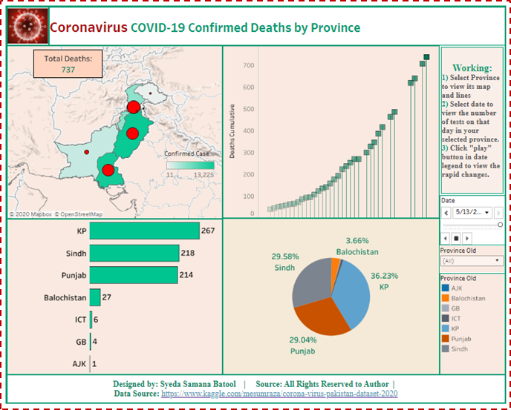

**Figure 4**

Figure 4 comprises of 4 graphs and 2 data legends:

***· Graphs:***

**Map of Total deaths and confirmed cases:**This map colour highlights the number of Total confirmed cases while the small bullets demonstrate the number of deaths.

**Lines of Deaths:**These lines depicts the gradual increase in the number of deaths.

**Bars of Deaths:**They portray a comparative analysis of number of deaths.

**Pie of Deaths:**It gives a percentage of the total deaths in each province.

***· Data Legends:***

**Date:**It enables the person to view the number of deaths on a specific date.

**Province**: It provides an effective way to select a province of your interest to view its particular graphs.

***· Observations:***

Figure 4 gives a visual illustration of increment in the number of total deaths due to covid-19. Date legend exhibits that total deaths on the onset of April were **40**, but till the 13th of may ,we had a total of **737** deaths. Furthermore, the lines depicts that number of deaths have got pace at the offset of April . Comparative bars dipicts that Khyber Pakhtunkhwa leads the number of deaths while Azad Kashmir by far has encountered only one death. Sindh and Punjab has almost same number of deaths. Pie chart portrays that Khyber Pakhtunkhwa has got **36.23 %** of total deaths.

***· Online Dashboard:***

**[Tableau Public](https://public.tableau.com/profile/syeda.samana.batool" \l "!/vizhome/ConfirmedDeathsFinal/ConfirmedDeaths" \t "_blank)**

[Edit description](https://public.tableau.com/profile/syeda.samana.batool" \l "!/vizhome/ConfirmedDeathsFinal/ConfirmedDeaths" \t "_blank)

[public.tableau.com](https://public.tableau.com/profile/syeda.samana.batool" \l "!/vizhome/ConfirmedDeathsFinal/ConfirmedDeaths" \t "_blank)

**5. Provincial Analysis of Number of Recoveries:**

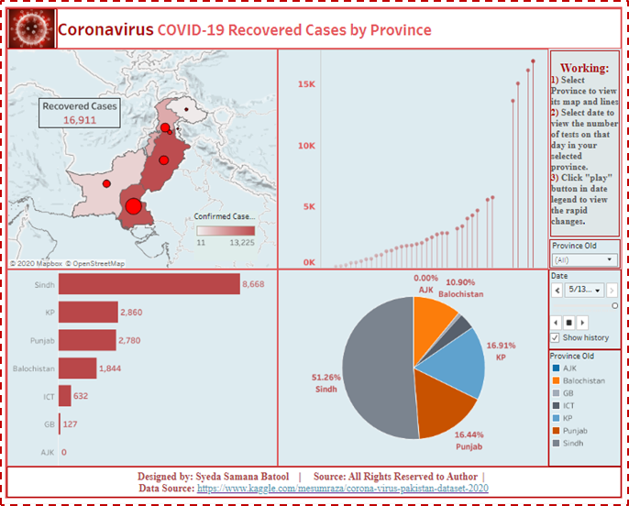

**Figure 5**

Figure 5 comprises of 4 graphs and 2 data legends:

***· Graphs:***

**Map of Recovered cases and confirmed cases:**This map colour highlights the number of Total confirmed cases while the small bullets demonstrate the number of Recoveries out of those who were confirmed.

**Lines of Recoveries:**These lines represents the extensive increment in the number of recoveries.

**Bars of Recoveries:**They portray a comparative analysis of recoveries.

**Pie of Recoveries:**It gives a percentage of the total recoveries in each province.

***· Data Legends:***

**Date:**It enables the person to view the number of recoveries on a specific date.

**Province**: It provides an effective way to select a province to view its graphs.

***· Observations:***

Figure 5 gives a visual display of colossal increase in the number of recoveries. With date legend, we have observed that the recovered cases at the beginning of april were **130**, but till the 13th of may we have reached **16,911** total recoveries. The lines shows that more people started to recover at the onset of May. Comparative bars illustrates that Sindh has got the largest number. Khyber Pakhtunkhwa and Punjab are almost at same locale by far. Azad Kashmir remains at the lowest position. Pie chart, we have observed that Sindh has got **51.26 %** of total recoveries.

***· Online Dashboard:***

**[Tableau Public](https://public.tableau.com/profile/syeda.samana.batool" \l "!/vizhome/RecoveredCasesFinal/RecoveredCases" \t "_blank)**

[Edit description](https://public.tableau.com/profile/syeda.samana.batool" \l "!/vizhome/RecoveredCasesFinal/RecoveredCases" \t "_blank)

[public.tableau.com](https://public.tableau.com/profile/syeda.samana.batool" \l "!/vizhome/RecoveredCasesFinal/RecoveredCases" \t "_blank)

**6. Provincial Analysis of Total Hospitals & Total Admitted:**

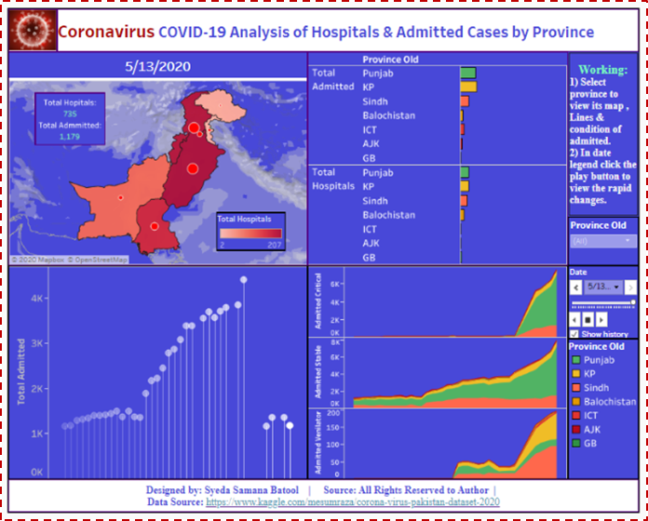

**Figure 6**

Figure 6 comprises of 4 graphs and 2 data legends:

***· Graphs:***

**Map of Total Hospitals and Total Admitted:**Colour of map highlights Total Hospitals while the small bullets demonstrate the number of admitted patients.

**Lines of Total admitted:**These lines represents the rapid increment in admitted cases.

**Bars of Total admitted and Total Hospitals :**They portray a comparative analysis of number of hospitals and admitted patients.

**Area charts of Admitted patients:**They represent the condition of admitted patients(stable , critical , ventilator) in each province.

***· Data Legends:***

**Date:**It enables the person to view the number of admitted patients on a specific date.

**Province**: It provides an effective way to select a province of one’s choice to view its visualizations.

***· Observations:***

Figure 6 depicts the total of Hospitals as well as the total of admitted patients. The total hospitals at the onset of April were **449** with almost **1158** admitted cases. Till 13th of May, hospitals reached a total of **735**. From the comparative bars we have observed that Punjab and Sindh have almost same number of hospitals and admitted patients. While Islamabad, Azad Kashmir and Gilgit Baltistan have very diminished amount. Area charts illustrates that Punjab has a largest number of stable and critical patients. Sindh also has a great number of stable patients along with lesser critical patients but most critical cases are on ventilator . Balochistan has more stable cases at the start. Islamabad has the same amount of stable and critical cases by far. Morevover, Gilgit Baltistan has the lesser number of critical patients as compared to stable with zero patients on ventilator.

***· Online Dashboard:***

**[Tableau Public](https://public.tableau.com/profile/syeda.samana.batool" \l "!/vizhome/HospitalsAdmitted/HospitalsandAdmitted" \t "_blank)**

[Edit description](https://public.tableau.com/profile/syeda.samana.batool" \l "!/vizhome/HospitalsAdmitted/HospitalsandAdmitted" \t "_blank)

[public.tableau.com](https://public.tableau.com/profile/syeda.samana.batool" \l "!/vizhome/HospitalsAdmitted/HospitalsandAdmitted" \t "_blank)

**7. Provincial Analysis of Inner View of Hospitals:**

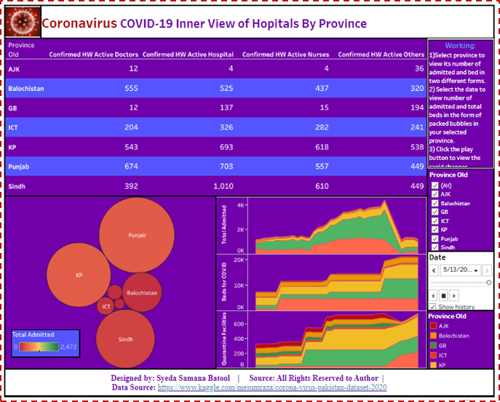

**Figure 7**

Figure 7 comprises of 3 graphs and 2 data legends:

***· Graphs:***

**Text table of Actives:**It portrays the total active hospitals ,doctors ,nurses and other hospital staff according to province.

**Packed bubbles of number of beds:**They depicts the number of beds in each province.

**Area charts of hospital facilities:**They portray a comparative analysis of number of beds and quarantine facilities.

***· Data Legends:***

**Date:**It enables the person to get a picture of inner view of hospitals on a specific date.

**Province**: It provides an effective way to select a province of your focus to view its graphs.

***· Observations:***

Figure 7 exhibits an inner picture of hospital conditions in Pakistan.Text table shows that the number of active doctors is the largest in Punjab province. Balochistan and Sindh almost has the same number of active doctors. Gilgit Baltistan and Azad Kashmir has the least number of active doctors. In case of active nurses Khyber Pakhtunkhwa is at the lead while Azad Kashmir still remains behind. Moreover, Sindh has the enormous number of active hospitals. In addition to that, packed bubbles represents that Khyber Pakhtunkhwa has the largest number of bed for covid-19 at the onset of April while till may Punjab leads in the number of beds i-e almost **7753**. While Azad Kashmir has the least number. Area charts we have illustrates that Khyber Pakhtunkhwa has the largest number of quarantine facilities, while Punjab and Sindh stands at the same locale. Gilgit Baltistan has the least number of quarantine facilities.

***· Online Dashboard:***

**[Tableau Public](https://public.tableau.com/profile/syeda.samana.batool" \l "!/vizhome/HospitalsInnerView/HopitalsInnerView" \t "_blank)**

[Edit description](https://public.tableau.com/profile/syeda.samana.batool" \l "!/vizhome/HospitalsInnerView/HopitalsInnerView" \t "_blank)

[public.tableau.com](https://public.tableau.com/profile/syeda.samana.batool" \l "!/vizhome/HospitalsInnerView/HopitalsInnerView" \t "_blank)

**8. Provincial Analysis of Returnees:**

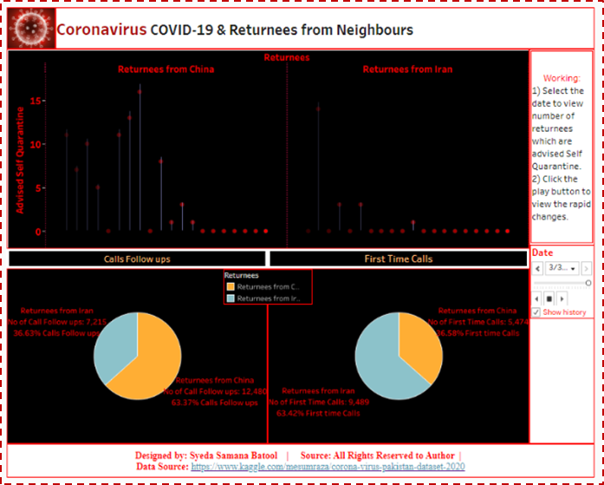

**Figure 8**

Figure 8 comprises of 3 graphs and 1 data legends:

***· Graphs:***

**Lines of Returnees vs Advised quarantine:**These lines gives a comparison between the returnees from China and Iran.

**Pie of first time calls:**They portray a comparative analysis of percentage of first time calls of new arrivals.

**Pie of calls follow ups:**They portray a comparative analysis of percentage of followed up calls of new arrivals.

***· Data Legends:***

**Date:**It enables the person to view the number of returnees on a specific date.

***· Observations:***

Figure 8 gives a comparison among the travelers which have returned to Pakistan from China and Iran. These two countries have the enormous number of cases in March. Lines, clearly shows that at the onset of march larger number returnees from china were advised to be quarantined than the returnees from Iran. Till the offset of March, no returnees were quarantined. Furthermore, Pie charts exhibitsthat first time calls of new arrivals were majorly from Iran’s Returnees i-e **63.42 %** , and Followed up calls of new Arrivals were majorly from the china’s returnees i-e **63.37%**.

***· Online Dashboard:***

**[Tableau Public](https://public.tableau.com/profile/syeda.samana.batool" \l "!/vizhome/ReturneesFromNeighbours/CallsandReturnees" \t "_blank)**

[Edit description](https://public.tableau.com/profile/syeda.samana.batool" \l "!/vizhome/ReturneesFromNeighbours/CallsandReturnees" \t "_blank)

[public.tableau.com](https://public.tableau.com/profile/syeda.samana.batool" \l "!/vizhome/ReturneesFromNeighbours/CallsandReturnees" \t "_blank)

**9. Provincial Analysis of Total Transmission:**

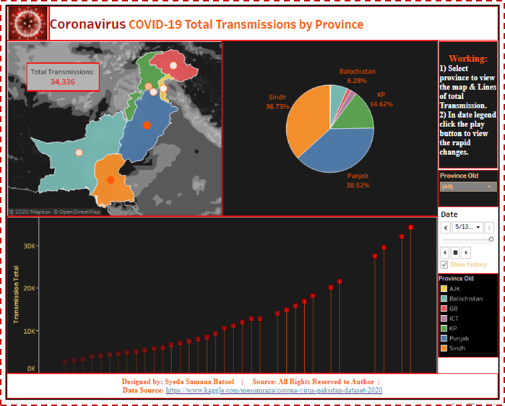

**Figure 9**

Figure 9 comprises of 3 graphs and 2 data legends:

***· Graphs:***

**Map of Total Transmission:**This map colour highlights the number of Total transmission in each province.

**Lines of Total Transmission:**These lines represents the rapid increase in the number of transmissions.

**Pie of Total transmission:**They represent the Transmission comparison between provinces.

***· Data Legends:***

**Date:**It enables the person to view the number of transmissions on a specific date.

**Province**: It provides an effectual way to pick a province of your choice to view its visualizations.

***· Observations:***

Figure 9 exhibits the rapid elevation in the Transmission of Covid-19. Using date legend, we have observed that the number of transmissions at the beginning of April were **2708**, but till the 13th of may we have reached **34,336** transmissions. Lines clearly depicts that the transmission was relatively low at the beginning of april and it has got pace on a constant rate till the mid of May. Pie chart illustrates that Punjab has the highest percent of transmissions i-e **38.52 %**, whereas, Azad Kashmir remains at the bottom locale.

***· Online Dashboard:***

**[Tableau Public](https://public.tableau.com/profile/syeda.samana.batool" \l "!/vizhome/TotalTransmissions/TotalTransmissions" \t "_blank)**

[Edit description](https://public.tableau.com/profile/syeda.samana.batool" \l "!/vizhome/TotalTransmissions/TotalTransmissions" \t "_blank)

[public.tableau.com](https://public.tableau.com/profile/syeda.samana.batool" \l "!/vizhome/TotalTransmissions/TotalTransmissions" \t "_blank)

**10. Provincial Analysis of Local and Foreign Transmissions:**

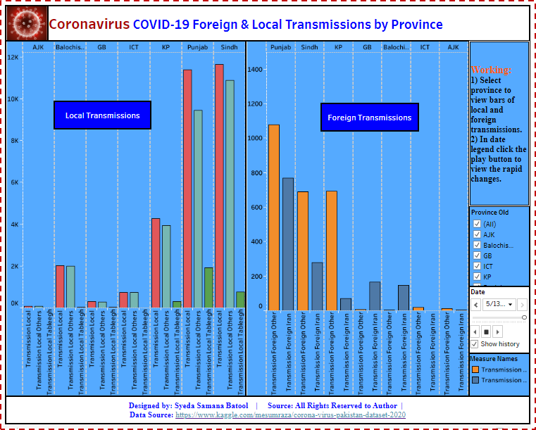

**Figure 10**

Figure 10 comprises of 2 graphs and 2 data legends:

***· Graphs:***

**Side by side bars of Local Transmissions:**They exhibits a comparative analysis of local transmissions.

**Side by side bars of foreign transmissions:**They portrayed a comparison of Foreign transmissions.

***· Data Legends:***

**Date:**It enables the person to view the analysis of foreign and local transmissions on a specific date.

**Province**: It enables one to select a province of interest and view its graphs.

***· Observations:***

Figure 10 demonstrates a comparative analysis of local and foreign transmissions. Bars clearly illustrates that Sindh leads the local transmissions followed by Punjab. If we observe further , it shows that transmission in Punjab is mostly due to Local tableeghees as compared to Sindh. While, Azad Kashmir has encountered least number of local transmissions by far. In case of foreign transmissions, Punjab still remains at the top. In Punjab , Sindh and Khyber Pakhtunkhwa , the major carrier of covid-19 seems to be other foreign returnees rather than Iran. But in Gilgit Baltistan and balochistan , transmission due to Iran returnees is greater than other Foreign returnees.

***· Online Dashboard:***

**[Tableau Public](https://public.tableau.com/profile/syeda.samana.batool" \l "!/vizhome/LocalForeignTransmissions/LocalForeignTransmissions" \t "_blank)**

[Edit description](https://public.tableau.com/profile/syeda.samana.batool" \l "!/vizhome/LocalForeignTransmissions/LocalForeignTransmissions" \t "_blank)

[public.tableau.com](https://public.tableau.com/profile/syeda.samana.batool" \l "!/vizhome/LocalForeignTransmissions/LocalForeignTransmissions" \t "_blank)

**Conclusions:**

Summing up, there is no doubt, we are facing an extreme circumstances. We have reached a grand total of covid-19 infectants in much lesser amount of time than Italy and china. Even the superpowers of the world are suffering badly from this pandemic as well while we are in the primitive stage of advancement with lesser number of healthcare facilities. From the analysis ,we have figured out that **Punjab** And **Sindh** are in danger zone. The citizens must act sensibly in this chaotic situation. We should take all the possible remedial measures in order to avoid this epidemic to its fullest. Hopefully, this covid-19 will be vanished from the world soon. But for the time being , stay home and socialize less in order to protect yourselves and your beloved ones.

**View Project Repository on Github:**

**[Syeda-Samana-Batool/DS\_project](https://github.com/Syeda-Samana-Batool/DS_project" \t "_blank)**

[Data visualizations on Covid-19 dataset. Contribute to Syeda-Samana-Batool/DS\_project development by creating an…](https://github.com/Syeda-Samana-Batool/DS_project" \t "_blank)

[github.com](https://github.com/Syeda-Samana-Batool/DS_project" \t "_blank)

**View Online Dashboards here:**

**[Tableau Public](https://public.tableau.com/profile/syeda.samana.batool" \l "!/" \t "_blank)**

[Edit description](https://public.tableau.com/profile/syeda.samana.batool" \l "!/" \t "_blank)

[public.tableau.com](https://public.tableau.com/profile/syeda.samana.batool" \l "!/" \t "_blank)

**Link to my Published Blog on Medium:**

<https://medium.com/@syedasamanabatool19/ocular-glimpse-of-covid-19-in-pakistan-using-tableau-e6d520d45900>